GRAPHICAL INTERFACES AND MySQL.
1. Database.
We need to create in MySQL a database called di. Within this database create a table that we will call clients with the following fields:
id: varchar (10)
notes: varchar (255);
Once the clients table has been created, we generate several records to test data.
2. Description of the program.
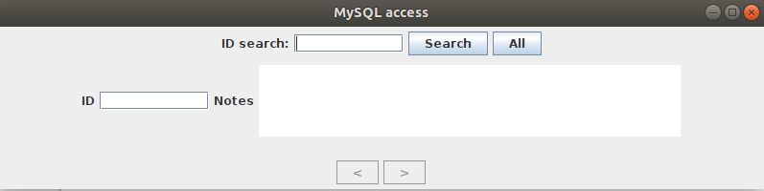

- The All button will allow us to access all the rows of the clients table and will enable the <and> buttons in order to move through the records.
- The search button will display the searched id and disable the scroll buttons.
3. Project structure.
We will create a structure like this:

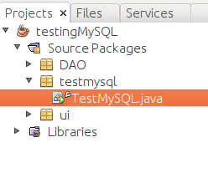

The TestMySQL class will contain the main of the project

3. DAO package.
In this package we will put the classes that will allow us access to the data:
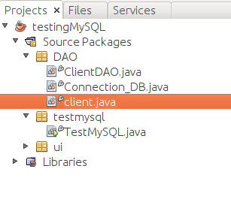

The description of each one of the classes:
- client.java - Renders an object to handle a row in the table.
- Connection_DB: will open and close connections to the di database.
- ClientDAO: will access the clients table and return a row in the form of a client object or the whole table in the form of a list of client objects.

The way to work with MySQL is seen in the data access module. There are many correct ways to do this, here is a possible solution.
NOTE: If the mysql driver is not installed, we will need to install it for the OS you use:

https://dev.mysql.com/downloads/connector/j/

https://zoomadmin.com/HowToInstall/UbuntuPackage/libmysql-java
https://ubuntu.pkgs.org/18.04/ubuntu-universe-amd64/libmysql-java_5.1.45-1_all.deb.html
If you don’t have permissions, copy the mysql-connector-java-5.1.45.jar jar it in your user folder. Then add it to the project in project properties-→Resolve problems.

3.1. Customer class.
The client class models a row of the table, it could well be:
package DAO;
public class client {
private String id;
private String notes;
public client () {
this.id = "";
this.notes = "";
}
public String getId () {
return id;
}
public void setId (String id) {
this.id = id;
}
public String getNotes () {
return notes;
}
public void set Notes (String notes) {
this.notes = notes;
}
}

3.2. The Conexion_DB class.
This class should provide us with valid connections to the database:
package DAO;
import java.sql. *;
public class Conexion_DB {
public Connection OpenConnection () throws Exception
{
Connection con = null; // install a connection
try {
String urlOdbc = "jdbc:mysql://localhost:3306/di?useUnicode=true&useJDBCCompliantTimezoneShift=true&useLegacyDatetimeCode=false&serverTimezone=UTC";

// create connection. NOTE in my case MySql user -> root, empty password
con = (java.sql.DriverManager.getConnection (urlOdbc, "root", ""));
return with;
} catch (Exception e) {// SQLException and ClassNotFoundException
e.printStackTrace ();
throw new Exception ("Connection could not be established" + e.getMessage ());
}
}
public void CloseConnection (Connection con) throws Exception
{
try {
if (con! = null) con.close ();
} catch (SQLException e) {
e.printStackTrace ();
throw new Exception ("It was impossible to close the connection" + e.getMessage ());
}
}
}

3.3. The ClientDAO class.
This class provides us with two methods:
- findById: returns the client we are looking for, if it exists.
- findAll: returns a list of client objects, one for each row in the table.
package DAO;
import java.sql. *;
import java.util. *;
public class ClientDAO {
public findById client (Connection to, cli client) throws Exception
{
client c = null;
PreparedStatement stmt = null;
ResultSet rs = null;
try {
stmt = con.prepareStatement ("SELECT * FROM clients WHERE id =?");
stmt.setString (1, cli.getId ());
rs = stmt.executeQuery ();
while (rs.next ()) {
c = new client ();
getClientRow (rs, c);
}
} catch (SQLException ex) {
ex.printStackTrace ();
throw new Exception ("There was a problem searching the client by DNI" + ex.getMessage ());
} finally
{
if (rs! = null) rs.close (); // We close the result
if (stmt! = null) stmt.close (); // We close the Statement
}
return c;
}
private void getClientRow(ResultSet rs, client cli) throws SQLException {
cli.setId (rs.getString ("id"));
cli.setNotes (rs.getString ("notes"));

}
public List <client> findAll (Connection con) throws Exception {
List <client> listClients = new ArrayList ();
Statement st = null;
ResultSet rs = null;
try {
st = con.createStatement ();
rs = st.executeQuery ("Select * from clients");
client cli = null;
while (rs.next ()) {
cli = new client ();
getClientRow (rs, cli);
clientList.add (cli);
}
} catch (SQLException ex) {
ex.printStackTrace ();
throw new Exception ("There was a problem searching the client “ + ex.getMessage ());
} finally
{
if (rs! = null) rs.close (); // We close the result
if (st! = null) st.close (); // We close the Statement
}
return CustomerList;
}
}

4. Package ui.
In this package will be the window and the listener to respond to the buttons. Until now we have created the listener as a class inside the frame class, in this case we will remove it outside since it is a listener with many lines of code. We will have, then, the following classes:
frame: class to represent the window.
Listener: class Listener that should be instantiated in the window.

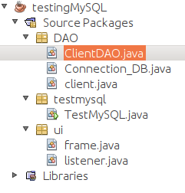

4.1. The frame class.
It is the class where we instantiate the Swing objects to create the graphical interface:
package ui;
import java.awt. *;
import java.awt.event. *;
import javax.swing. *;

import static javax.swing.JFrame.EXIT_ON_CLOSE;
public class frame extends JFrame {
private JPanel panel1 = new JPanel ();
private JPanel panel2 = new JPanel ();
private JPanel panel3 = new JPanel ();
private JPanel panel4 = new JPanel ();
private JButton backwards, forward, search, all;
private JLabel e1, e2, e3;
private JTextField id, idSearch;
private JTextArea notes;
private listener myListener; // this line will fail until the listener class is created
public frame () {
// usual properties of windows
setSize (800,200);
setTitle ("Access to MySQL");
setDefaultCloseOperation (EXIT_ON_CLOSE);
// instance of design panels
panel1.setLayout (new BorderLayout ());
panel2.setLayout (new FlowLayout ());
panel3.setLayout (new FlowLayout ());
panel4.setLayout (new FlowLayout ());
add (panel1);
panel1.add (panel3, BorderLayout.SOUTH);
panel1.add (panel2, BorderLayout.CENTER);
panel1.add (panel4, BorderLayout.NORTH);
// south panel with scroll buttons
backwards = new JButton ("<");
forward = new JButton (">");
panel3.add (backwards);
panel3.add (forward);

// central panel with data
e1 = new JLabel ("ID");
id = new JTextField (10);
panel2.add (e1);
panel2.add (id);
e2 = new JLabel ("Notes");
notes = new JTextArea (5, 40);
panel2.add (e2);
panel2.add (notes);
// north panel with searches
e3 = new JLabel ("ID to find:");
searchID = new JTextField (10);
search = new JButton ("Search");
all = new JButton ("All");
panel4.add (e3);
panel4.add (searchID);
panel4.add (search);
panel4.add (all);
// add listeners, this line will fail until the listener class is not created
myListener = new listener (id, notes, idSearch, backwards, forward, search, all);
backwards.addActionListener (myListener);
forward.addActionListener (myListener);
search.addActionListener (myListener);
all.addActionListener (myListener);
// initially motion buttons disabled
forward.setEnabled (false);
backwards.setEnabled (false);
}
}

4.2. The listener class.
The listener to respond to buttons:
package ui;

import DAO.ClienteDAO;
import DAO.Conexion_DB;
import DAO.client;
import java.awt.event. *;
import java.sql. *;
import java.util.List;
import javax.swing. *;

public class listener implements ActionListener {
private JTextField id, idSearch;
private JTextArea notes;
private JButton backwards, forward, search, all;
private List <client> clients;
private int position;
public listener (JTextField id, JTextArea notes, JTextField idSearch,
JButton backwards, JButton forward, JButton search, JButton all) {
this.id = id;
this.notas = notes;
this.idBuscar = idBuscar;
this.backwards = backwards;
this.forward = forward;
this.search = search;
this.all = all;
position = 0;
}
public void actionPerformed (ActionEvent e) {
customer c = new customer ();
// FIND A CLIENT
if (e.getSource () == this.search) {
// in searches disabled movement buttons
forward.setEnabled (false);
backwards.setEnabled (false);
try {
DB_Connection DB_Connection = new DB_Connection ();
Connection with = DB_connection.OpenConexion ();
CustomerDAO customerDAO = new CustomerDAO ();
c.setId (idBuscar.getText ());
c = clientDAO.findById (with, c);
conexion_DB.CerrarConexion (with);
} catch (Exception ex) {
ex.printStackTrace ();
}
}
// LOAD ALL CLIENTS
if (e.getSource () == this.all) {
// on all motion buttons enabled
forward.setEnabled (true);
backwards.setEnabled (true);
position = 0;
// All clients:
try {
DB_Connection DB_Connection = new DB_Connection ();
Connection with = DB_connection.OpenConexion ();
CustomerDAO customerDAO = new CustomerDAO ();
customers = customerDAO.findAll (with);
conexion_DB.CloseConexion (with);
// charge the first customer
position = 0;
c = customers.get (position);
} catch (Exception ex) {
ex.printStackTrace ();
}
}
//AHEAD
if (e.getSource () == this.ahead) {
position ++;
if (position == customers.size ()) {
position--;
}
c = customers.get (position);
}
//BEHIND
if (e.getSource () == this.backwards ) {
if (position> 0) {
position--;
}
c = customers.get (position);
}
update (c);
}

private void update (client c) {
this.id.setText (c.getId ());
this.notas.setText (c.getNotas ());
}
}

5. The TestMySQL class.
This class contains the main and only instantiates the window:

import ui.frame;

public class MySQLTest {
public static void main (String [] args) {
frame f = new frame ();
f.setVisible (true);
}
}

